**Project Proposal**

**Fine Payment Management System for Police Department**

**Sri Lanka**

**INTE 21533-Information System Modelling**

**INTE 21543 Interactive Application Design & Development**

**Student Group: 09**

**Student No. Name**

Handapangoda L. E. IM/2018/028

Wimarsha D.G.H. IM/2018/096

Wijesinghe A.V.A.P. IM/2018/094

Perera T.P.S.S. IM/2018/061

Afshan M.A.N. IM/2018/005

Ranidu M. IM/2018/066

**Bachelor of Science Management & Information Technology**

**Department of Industrial Management**

**Faculty of Science**

**University of Kelaniya**

**21st June 2021**

**Fine Payment Management System**

# Fine Imposing in Sri Lanka

According to the information available on the Ministry of Transport, in Sri Lanka, there are over 700,000 driving licenses in 2019. According to the reports of the Sri Lanka police, numerous traffic violations are reported every day. In that case, actions will be taken to impose a fine on drivers for their offenses. Under the current system, drivers will be inconvenienced when paying fines, and the current process is wasting their time.

# Fine Imposing Process

Currently, the Police department of Sri Lanka uses a completely manual system for the fine imposing and the fine payment process. The current process as follows.

The traffic police officers monitor vehicle driving and looking for drivers who violate the traffic rules. When the police officers notice a driver, who violated a traffic rule, they order the driver to stop the vehicle. Then the police officers take the drivers information like identity card and driving license information. After that, they issue a spot fine statement to the driver and confiscate the driver's license.

Then the driver needs to obtain a fine payment form from the traffic division of the police station. To obtain that form the driver should provide the spot fine permit to the police station. After obtaining the fine payment form, the driver visits the post office and settle the payment. Then he gets a paid receipt as the proof of the payment.

After making the payment the driver goes to the police station, shows receipt and police return driving license.

The driver can use the spot fine permit as a temporary license up to 14 days. If the driver could not make the payment within 14 days, he/she will be directed to the court.

# Problem Definition

We have identified several problems in existing fine payment system because it is not an automation system and that creates many difficulties to the day-to-day activities of general public. According to the Sri Lanka’s law, when driver breaks a traffic rule while driving his/her vehicle, the police confiscate the drivers driving license and issue a spot fine statement. The problems we identified in the current system as follows,

* The driver has to visit the police station.
* The driver has to provide the spot fine permit.
* The driver has to visit post office and make the payment.
* The driver has only 14 days to complete the above task which takes a long time, otherwise, the driver will be directed to court.
* The diver must visit the respective police station that we have identified as a considerable time waste from the drivers’ side if he breaks the traffic rule far away from his residential area.

# Objectives of the Proposed System

To maximize the efficiency of the existing manual traffic fine system, the suggested method proposes to implement a developed system using C#. In the existing system mainly, drivers face many difficulties. For instance, when a driver is caught for a traffic fine in an area far away from his residence, he has to come back to the police station which issued the spot fine statement to get his license. This is a main drawback in the prevailing traffic system.

As a solution for this, a system with unique functionalities is proposed to be developed. The system will be implemented to pay the fines online or sending the slip after bank deposits and verify the payment without visiting the police station.

The system provide facility to deliver the license back to the driver after the payment is done accordingly. Furthermore, the system is intended to have a user-friendly graphical user interface and the system will also provide statistical information when required.

# Scope of Project

The project will cover the spot fine statement issuing and the fine payment process. It will computerize both activities currently done by the drivers and police officers manually. However, the system will not provide facilities to make fine payments at the police stations and it will not send any reminders to drivers about the deadline unless they visit the website and login using their license number.

# Feasibility Study

## Financial Feasibility

The Fine payment management system has a shared database that facilitates the accessibility to the necessary data through the internet. Therefore, to implement the system, there will be a cost in purchasing a shared database service.

Apart from that, the proposed system consists of a web application that provides the online payment facility by using the Payhere payment gateway service. For that, the system will have an associated hosting cost and Payhere account purchasing cost. Since the system will use small multimedia data transfer like payment slips, bandwidth requirement and server storage of the hosting plan is low. In purchasing the Payhere payment gateway, it is better to buy a Payhere premium plan to avoid the monthly payment limit.

The Associated Costs as follows (Estimated)

The budget for the proposed system is Rs:150,000/= (Assumed that the Police department has already agreed with that price)

Besides the above costs, there will be many benefits for both the police department and drivers in Sri Lanka. The police department will be able to keep all data collected from all police stations in one place and generate statistical reports when required. The drivers will be able to save a large amount of their time and a more convenient way to pay their fines. This project is financially feasible, because the estimated cost is lower than the budget.

## 6.2 Technical Feasibility

Fine Payment Management system is a computer-based application. Additionally, it has a mobile application and a web-based application as well. This project is associated with following main technologies and tools.

* Visual Studio
* Payhere Payment Gateway
* MySQL
* Xamarin Mobile app development
* HTML
* CSS
* JS
* Diagram drawing and UI Designing tools
* Draw.io
* Figma

Each of the above technologies is freely available and required technical skills are manageable. For development and testing purposes the website will initially be published in a free web hosting space and a free MySQL service will be used. The payment gateway service provides a sandbox feature where we can make virtual payments for the testing purposes of the application. For later implementation, the system will be hosted in a paid web service and the system will use a database service and Payhere premium account.

From these, it is clear that the project is technically feasible.

# Business Activity Model & Context Diagram

## Business Activity Model

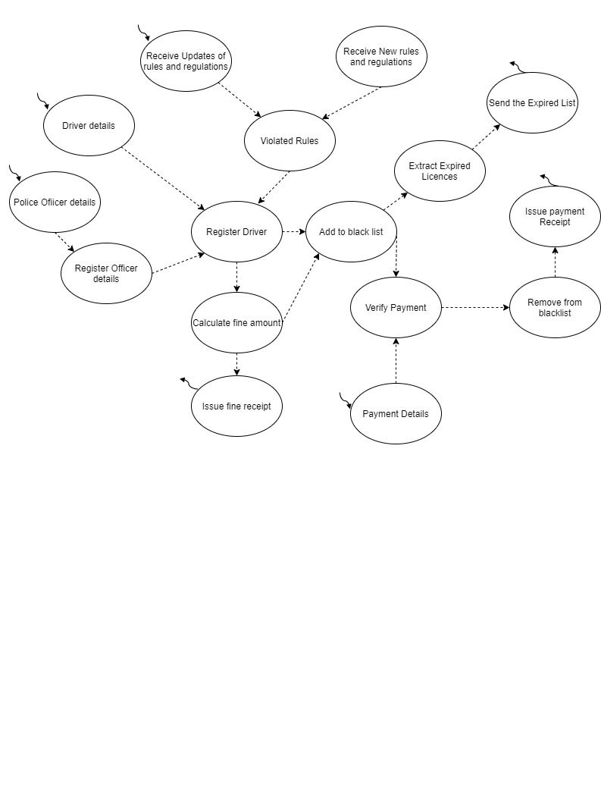

## 7.2 Context Diagram

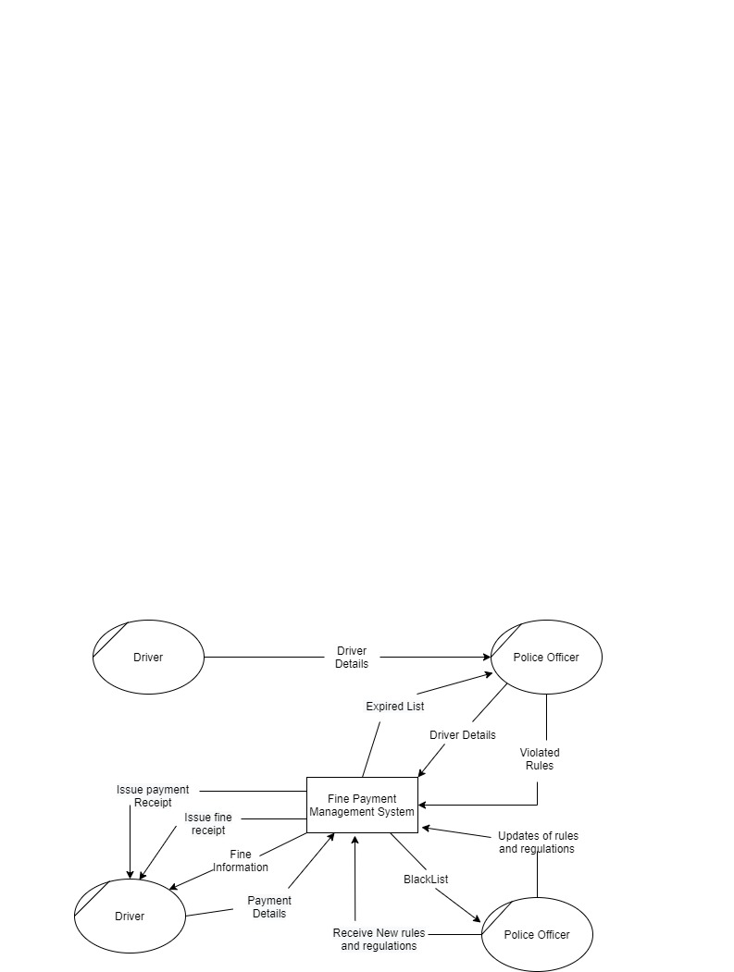

# User Stories

|  |  |
| --- | --- |
| User ID | User Story |
| US-01 | As a driver when I violated a traffic rule and when the police checkpoint stopped me, I would give my information to the checkpoint. The information I would provide consists of my Driving license details, NIC details and additional information required by the police checkpoint. When the police officers issue the fine receipt after getting my details, I will have to leave my license with them and accept the spot fine statement as my temporary license until I make the fine payment. Later I will go to the police station and receives a fine payment form by providing the spot fine statement I received previously. After getting the fine payment form receipt I will go the post office and make the payment. After making the payment, I will go to the police station to take my license back by showing the paid receipt I received from the post office. |
| US-02 | I am a police officer. When driver violated traffic rules. I stopped the driver and request his or her details. At that moment I check license details, NIC details, and vehicle details. After getting details of the diver, I issued a fine receipt and kept his license. The spot fine permit issued, is considered as a temporary license until the driver pays the fine. After that, when a driver come to the police station and request a payment form by providing his/her spot fine permit, I will give a fine payment form to him/her. After that person returned with the paid receipt given by the post office, I verify the payment and release his/her license by returning their license. |

# Requirements Specification

## Functional Requirements

|  |  |  |
| --- | --- | --- |
| User_ID | Requirement_ID | Requirement |
| US-02 | FRQ-01 | Should be able to enter driver details and register him/her in the system. |
| US-02 | FRQ-02 | Should be able to select all rules violated by the driver. |
| US-02 | FRQ-03 | Should be able to issue a spot fine statement to a driver. |
| US-02 | FRQ-04 | Should be able to get a list of drivers who made the payment. |
| US-01 | FRQ-05 | Should be able to get details of the spot fine information. |
| US-01 | FRQ-06 | Should be able to make an online payment or submit the payment slip. |
| US-01 | FRQ-07 | Should be able to get a payment receipt as a proof of the payment. |

## Non-Functional Requirements

|  |  |  |
| --- | --- | --- |
| User ID | Requirement ID | Requirement |
| US-01 | NFRQ-01 | Shall be able to see the fine payment history |
| US-02 | NFRQ-02 | Shall be able to get statistical data |
| US-01 | NFRQ-03 | Shall be able to see the deadline of the payment |
| US-02 | NFRQ-04 | Shall be able to sort paid and unpaid fine list. |

Other than above non-functional requirements, the system has following non-functional requirements as well.

* The system should be simple and operatable for a user who as a general knowledge on operating computers and smartphones.
* It is good to have a simple and user-friendly interface for the application and the website.
* It is good to available system in all three languages Sinhala, Tamil and English which are commonly used in Sri Lanka.

# References

GIC, 2009. *Goverment Information Centre.* [Online]   
Available at: https://gic.gov.lk/gic/index.php/en/component/info/?id=475&catid=65&task=info  
[Accessed 20 June 2021].

Tennage, P., 2017. *Sample Software Engineering Feasibility Study.* [Online]   
Available at: https://www.slideshare.net/PasinduTennage/sample-software-engineering-feasibility-study-report  
[Accessed 19 June 2021].